**TASK 02:**

* Connect with an instance using SSH on Windows using Putty

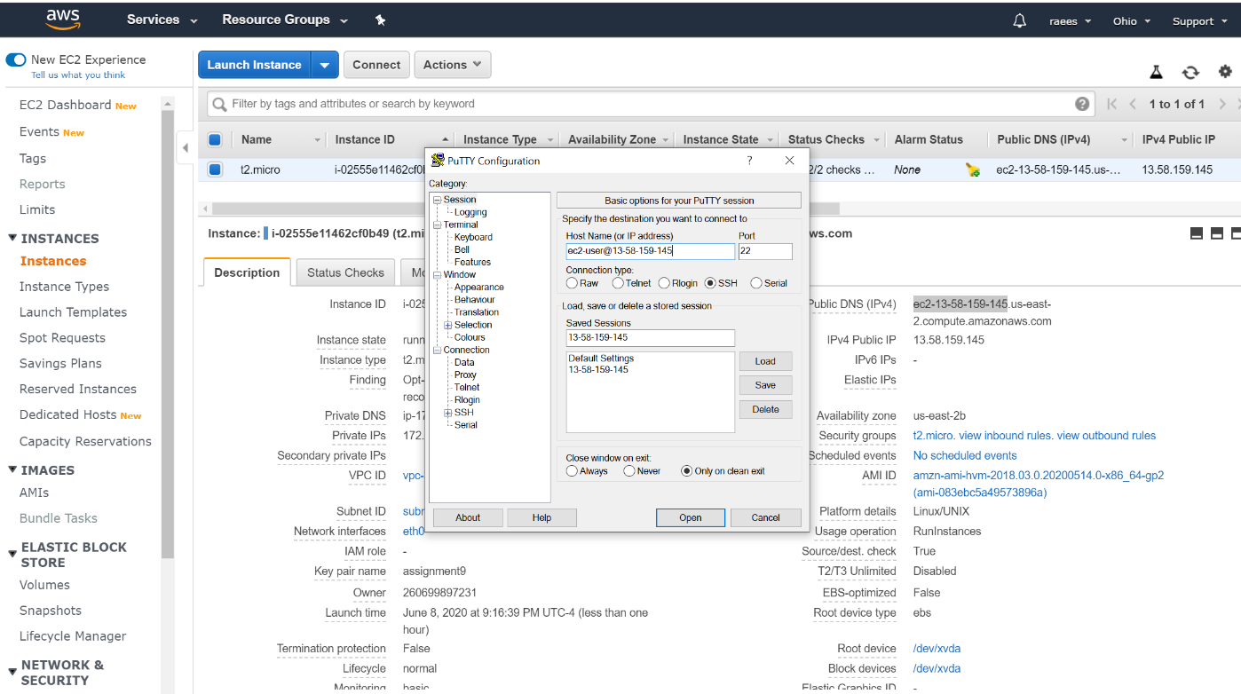

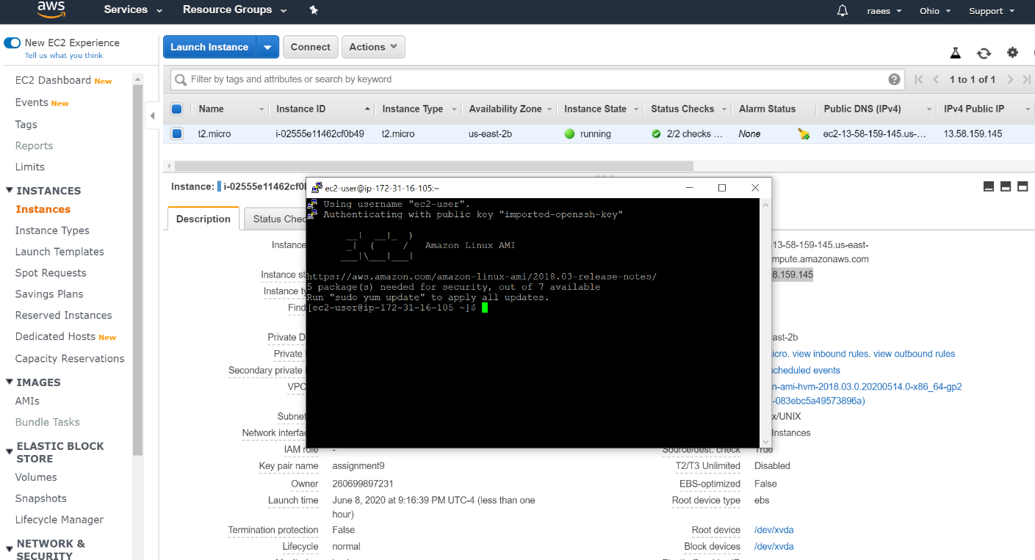

**TASK 03:**

* Install Apache Web Server

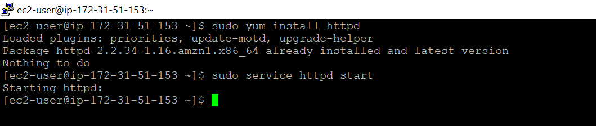

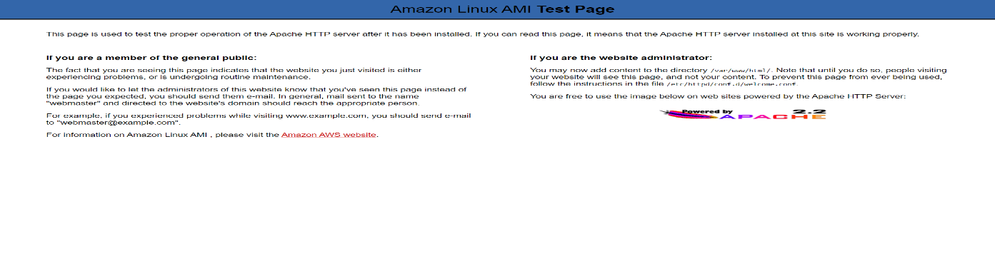Ru

n the Public IP and see the output

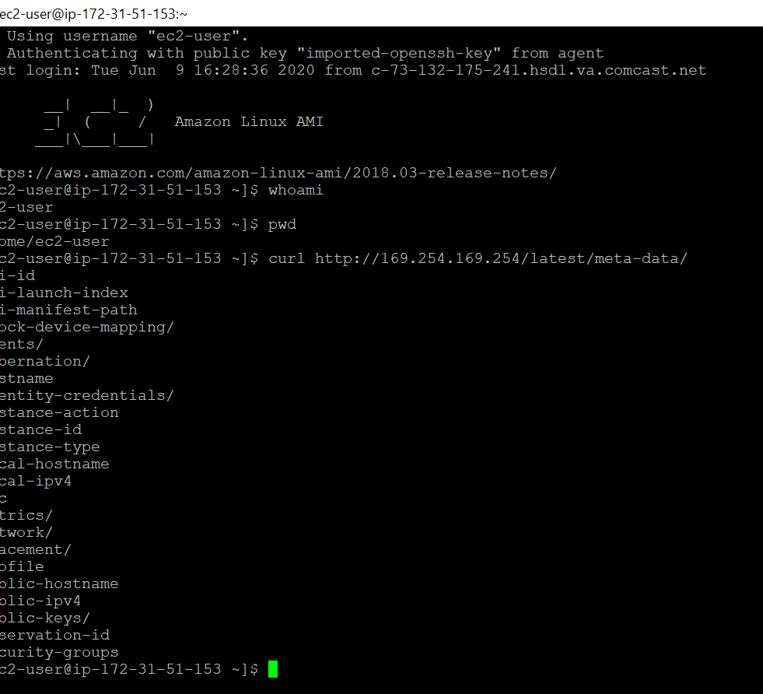

Create three more files in the same directory /var/www/html/

Home.html

payment.html

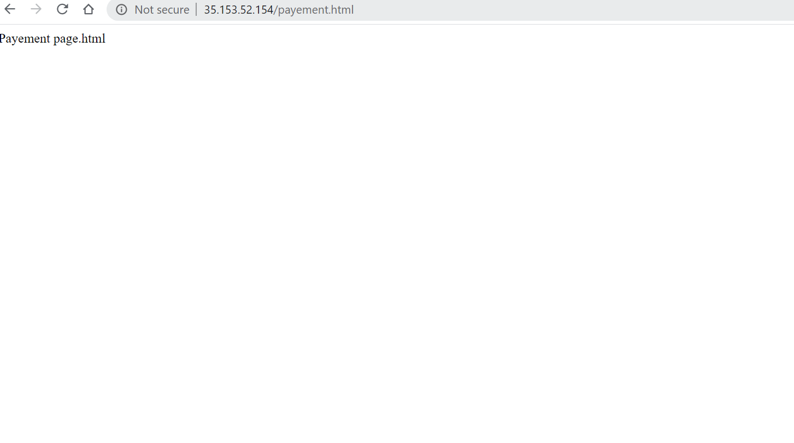Login.html

